49TH ANNUAL
GOLF OUTING
Join us Monday June 6, 2022
at Atlantic City Country Club
Northfield, NJ

Featuring a buffet lunch, on-course refreshments, cocktails and a
delicious dinner.
11:00 am
Registration

11:30 am – 12:30 pm
Buffet Lunch

12:30 pm
Shotgun Start

5:00 pm-6:00pm
Cocktails

6:00 pm
Dinner/Awards/Raffles

Spend the day relaxing and networking with fellow SJMCA members and guests

4 MAN
SCRAMBLE
FORMAT

- Each player hits own tee shot

- The best tee shot is selected and each golfer on the team hits from that spot

- The same format is followed for all succeeding shots until on the green

- All players putt from the best spot on green until hole is finished

- Only 1 score is put on scorecard for each hole
Prizes Awarded
1st, 2nd, 3rd Place Teams
2 holes closest to pin
2 holes longest drive

Raffle Prizes

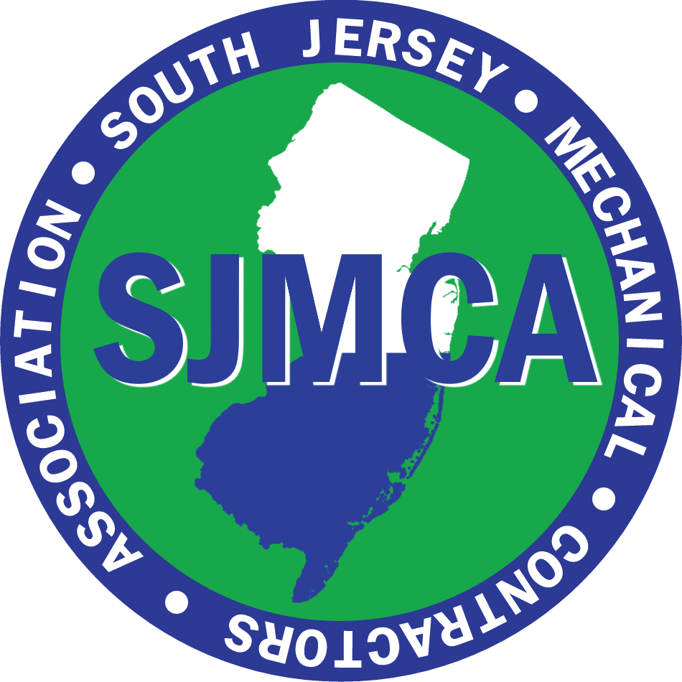

South Jersey Mechanical Contractors Association

49th ANNUAL
GOLF OUTING

JUNE 6, 2022

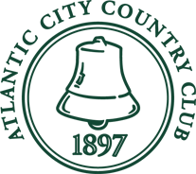

One Leo Fraser Drive
Northfield, NJ 08225
P: 609-236-4400
www.accountryclub.com

